**Excerpts from Happ’s research paper, which investigated discounted cash flow models of community banks’ relationships with banking characteristics, regional characteristics of their locations, and inflation.**

Gregory Happ

**Excerpt I**

**Abstract**

This paper analyzes whether a commercial bank’s value is affected by the characteristics of the community where it is located. A bank’s discounted cash flow model was assumed to be representative of its inherent value as dictated by the literature. The delineation used to capture the location value was the poverty level, and if the said location was urban or rural. The study found, utilizing ordinary least squares, that between 2003-2007,discounted cash flow models of small, commercial banks were increased by being at a rural location. However, poverty levels were not found to be statistically significant. Additionally, discounted cash flow models were increased by having a higher return on equity, and more assets. Further, the discounted cash flow models were decreased by higher tier-1 risk-based capital ratios, higher consumer price indexes, higher amounts of non-performing loans, and an urban location. Finally, banks’ return on equity was increased by higher tier-1 risk-based ratios, leverage, and return on assets. The findings regarding geographic location’s relationship with bank value is a contribution to the literature as previous academic research has not analyzed the relationship.

**Excerpt II**

**Table 2** Correlation and scatterplot matrix

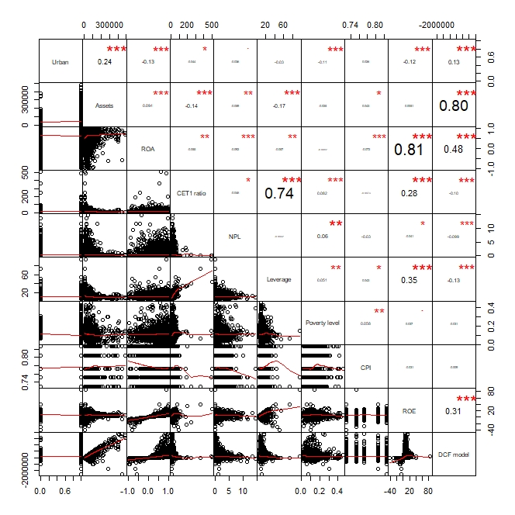

The researcher created the combined correlation and scatterplot matrix, Table 2. Only variables used in the subsequent three regressions were included. The variables are urban or rural location, assets, return on assets, tier-1 risk-based capital ratio, non-performing loans, leverage, poverty level, CPI, return on equity, and DCF model value.

High degrees of positive correlations were found between:

* + assets and the DCF model (0.80)
  + return on assets and return on equity (0.81)
  + tier-1 risk-based capital ratio and leverage (0.74)

Moderate degrees of positive correlations were found between:

* + return on assets and the DCF model (0.48)
  + leverage and return on equity (0.35)
  + return on equity and the DCF model (0.31)

**Excerpt III**

**Table 5** Regression results for discounted cash flow models, with banking characteristics, ROE, CPI, and location variables included as independent variables



DCF models were regression tested using tier-1 risk-based capital ratios, non-performing loans, return on equity, assets, and location variables (urban or rural, poverty level, cost of living, state, and city) as explanatory variables. The results suggest that the cost of living, tier-1 risk-based capital ratios, non-performing loans, return on equity, assets, and if the location was urban or rural were statistically significant in explaining DCF models of commercial banks. The results do not suggest that poverty levels are statistically significant in explaining DCF models of commercial banks. Higher return on equity and assets were found to increase DCF models. Higher costs of living, tier-1 risk-based capital ratios, non-performing loans, and having an urban location were found to decrease DCF models.